Title or Task: | Graphics & Design
Description: | Working with Images
Files Required | None
Suitable for Classes: | All
Area: | Technology & Enterprise
Teacher: | Mr Peter Faulks
Timeline | Information Sheet with a few questions

Date Due:

Task Brief:
Outcomes: | Students understand the basic image types

Items highlighted in yellow are tasks for you to complete
Items in Blue are help tips



TASK Working with Images

Save this document at images_surname.doc

(surname = your surname)

Work through the sections and continue to save your document and image files as you go.
Image resolution
All images displayed on a computer screen or printed from a printer are created using a series of dots or pixels. The more pixels per inch (DPI) the better the image, but larger the image size!

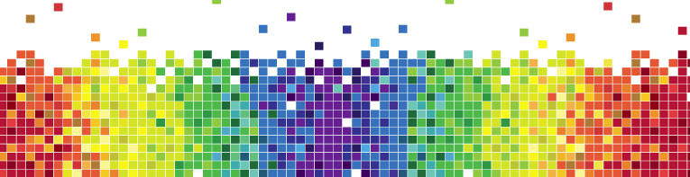
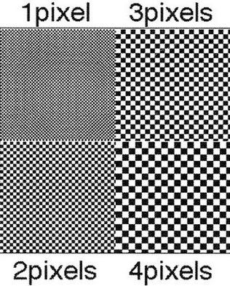

Good Quality Poor Quality
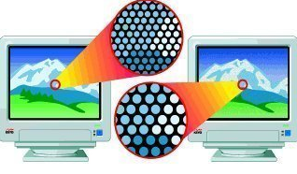

Resolution is the term used to describe the representation and quality of the image digitally. Resolution affects how various devices, like printers and monitors, display the digital image, and how image software controls and manipulates the image.
In digital media terms there are three different types of resolution:

• colour depth
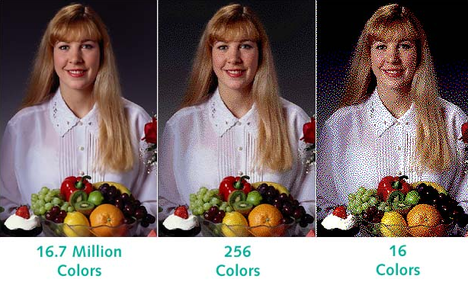

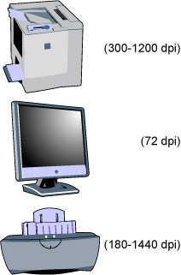 Various equipment and resolution

Device resolution
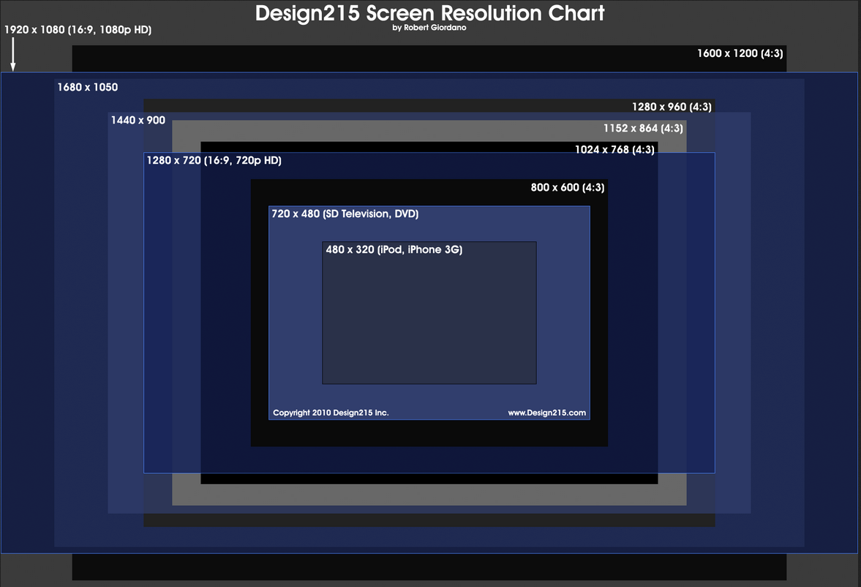

• image resolution.

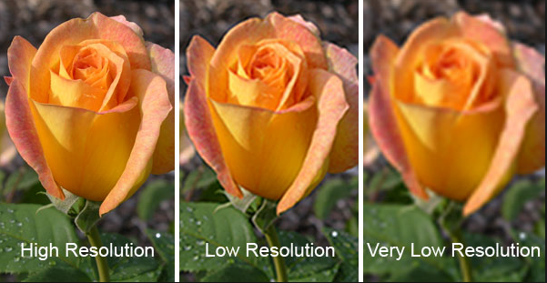

You would not wish to see n images as poor as the one on the left

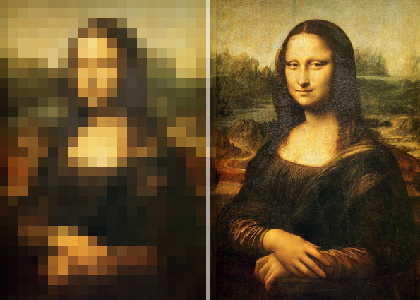

Use the Parrot image below
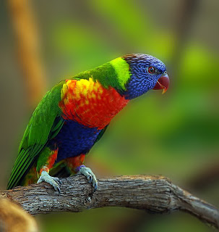 Parrots high resolution.jpg

and change the resolution to the lowest that you feel is acceptable Insert your low res image after this one

Each term describes resolution in a different way depending on how the image is being used.

Here is my low res image =

Digital Image File Types Explained
http://www.wakeforest.edu/~matthews/misc/graphics/formats/formats.html

JPG, GIF, TIFF, PNG, BMP. What are they, and how do you choose? These and many other file types are used to encode digital images. The choices are simpler than you might think.
Part of the reason for the plethora of file types is the need for compression. Image files can be quite large, and larger file types mean more disk usage and slower downloads. Compression is a term used to describe ways of cutting the size of the file. Compression schemes can by lossy or lossless.
Another reason for the many file types is that images differ in the number of colors they contain. If an image has few colors, a file type can be designed to exploit this as a way of reducing file size.

Lossy vs. Lossless compression
You will often hear the terms "lossy" and "lossless" compression. A lossless compression algorithm discards no information. It looks for more efficient ways to represent an image, while making no compromises in accuracy. In contrast, lossy algorithms accept some degradation in the image in order to achieve smaller file size.
A lossless algorithm might, for example, look for a recurring pattern in the file, and replace each occurrence with a short abbreviation, thereby cutting the file size. In contrast, a lossy algorithm might store color information at a lower resolution than the image itself, since the eye is not so sensitive to changes in color of a small distance.

Number of colors
Images start with differing numbers of colors in them. The simplest images may contain only two colors, such as black and white, and will need only 1 bit to represent each pixel. Many early PC video cards would support only 16 fixed colors. Later cards would display 256 simultaneously, any of which could be chosen from a pool of 224, or 16 million colors. New cards devote 24 bits to each pixel, and are therefore capable of displaying 224, or 16 million colors without restriction. A few display even more. Since the eye has trouble distinguishing between similar colors, 24 bit or 16 million colors is often called TrueColor.

The file types
TIFF is, in principle, a very flexible format that can be lossless or lossy. The details of the image storage algorithm are included as part of the file. In practice, TIFF is used almost exclusively as a lossless image storage format that uses no compression at all. Most graphics programs that use TIFF do not compression. Consequently, file sizes are quite big. (Sometimes a lossless compression algorithm called LZW is used, but it is not universally supported.)
When should you use each?
TIFF
This is usually the best quality output from a digital camera. Digital cameras often offer around three JPG quality settings plus TIFF. Since JPG always means at least some loss of quality, TIFF means better quality. However, the file size is huge compared to even the best JPG setting, and the advantages may not be noticeable.

A more important use of TIFF is as the working storage format as you edit and manipulate digital images. You do not want to go through several load, edit, save cycles with JPG storage, as the degradation accumulates with each new save. One or two JPG saves at high quality may not be noticeable, but the tenth certainly will be. TIFF is lossless, so there is no degradation associated with saving a TIFF file.

Do NOT use TIFF for web images. They produce big files, and more importantly, most web browsers will not display TIFFs.

PNG is also a lossless storage format. However, in contrast with common TIFF usage, it looks for patterns in the image that it can use to compress file size. The compression is exactly reversible, so the image is recovered exactly.
PNG: Stands for Portable Network Graphic used for displaying colour image files on the web. PNG files support transparency like GIF but offer twice the colour depth at 32 bits. Along with improved image compression this format allows special image information to be saved with the file.

When should you use each?
PNG
PNG is of principal value in two applications:
1. If you have an image with large areas of exactly uniform color, but contains more than 256 colors, PNG is your choice. Its strategy is similar to that of GIF, but it supports 16 million colors, not just 256.
2. If you want to display a photograph exactly without loss on the web, PNG is your choice. Later generation web browsers support PNG, and PNG is the only lossless format that web browsers support.
PNG will eventually replace GIF, but GIF is still more widely used on the web, since even old web browsers support it.
PNG: Stands for Portable Network Graphic used for displaying colour image files on

PNG-24 gives better transparent backgrounds
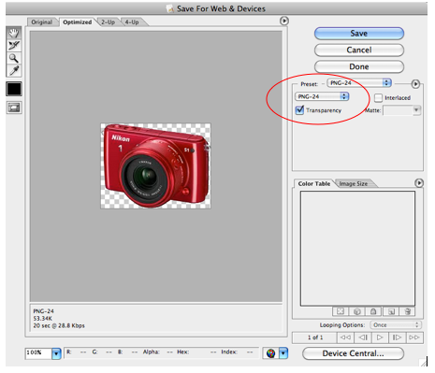

GIF creates a table of up to 256 colors from a pool of 16 million. If the image has fewer than 256 colors, GIF can render the image exactly. When the image contains many colors, software that creates the GIF uses any of several algorithms to approximate the colors in the image with the limited palette of 256 colors available. Better algorithms search the image to find an optimum set of 256 colors. Sometimes GIF uses the nearest color to represent each pixel, and sometimes it uses "error diffusion" to adjust the color of nearby pixels to correct for the error in each pixel.
GIF achieves compression in two ways. First, it reduces the number of colors of color-rich images, thereby reducing the number of bits needed per pixel, as just described. Second, it replaces commonly occurring patterns (especially large areas of uniform color) with a short abbreviation: instead of storing "white, white, white, white, white," it stores "5 white."
Thus, GIF is "lossless" only for images with 256 colors or less. For a rich, true color image, GIF may "lose" 99.998% of the colors.
When should you use each?
GIF
If your image has fewer than 256 colors and contains large areas of uniform color, GIF is your choice. The files will be small yet perfect. Here is an example of an image well-suited for GIF:
Do NOT use GIF for photographic images, since it can contain only 256 colors per image.

GIF format: (pronounced giff) this file format was developed especially for on-line use. The acronym stands for Graphic Interchange Format. GIF files are cross platform and compressed, making them ideal for use on web pages. Images using the GIF format are limited to a colour depth of only 8 bits or 256 colours but, unlike JPEG, will permit a colour to be made transparent.
Compression is very important on the internet because of the time taken to download images. If the images and graphics on a web page have very small file sizes, they will download onto a user’s computer quicker. Large files may take much longer to download.
The compression scheme used for GIF files is called ‘lossless’. This means that the quality of the image is not altered when the file is compressed. This lossless compression scheme is called Lempel-Ziv-Welch or LZW. This compression scheme works well for images with large flat areas of colour or images that have very small variations in tone and colour. It is very good at reproducing images that have been computer generated. Therefore the GIF file format is not suitable for photographic images.
LZW compression achieves very high compression ratios but with a limited colour depth. The LZW compression scheme looks at the sequence of bits used to create the image. Any repeating patterns are given a single value. This value is then used every time the same pattern repeats, this technique does not remove data, so is called ‘lossless’.
GIF image files can be saved with one colour being transparent. Transparency in an image can stop it appearing with a particular colour. Remember, image files are rectangular which means that when placed on a background, the edges of the rectangle can be seen. If for example, the colour of the rectangle is white, it would be visible on a black background. Using the GIF format means white can be set to transparent and the black background will show through.
It is also possible to make a GIF image interlaced, that is they are blended together. Interlaced images transmit over the internet as a series of layers. These layers build up to increase the quality of the image over time, allowing the user to continue scrolling while the image loads on the screen. These layers can also be used to create animations. Each frame of an animation can be created on a different layer, and then viewed in quick succession to give the effect of motion.

GIF characteristics:
• Best used for images with large areas of solid colours like shapes, simple pictures, logos and text.
• Designed to produce small files, making them the best format for transmitting over the internet.
• Can be interlaced and animated
• Can have a colour set to be transparent
• Have a limited colour depth of 8 bits (256 colours)
• Not suitable for natural or photographic images. Some very small photographs can use the format providing the size is less than approximately 30mm x 30mm.

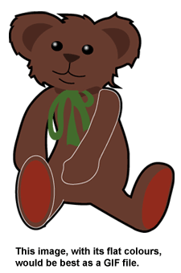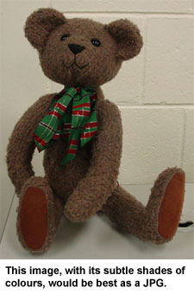
JPG is optimized for photographs and similar continuous tone images that contain many, many colors. It can achieve astounding compression ratios even while maintaining very high image quality. GIF compression is unkind to such images. JPG works by analyzing images and discarding kinds of information that the eye is least likely to notice. It stores information as 24 bit color. Important: the degree of compression of JPG is adjustable. At moderate compression levels of photographic images, it is very difficult for the eye to discern any difference from the original, even at extreme magnification. Compression factors of more than 20 are often quite acceptable. Better graphics programs, such as Paint Shop Pro and Photoshop, allow you to view the image quality and file size as a function of compression level, so that you can conveniently choose the balance between quality and file size.
When should you use each?
JPG
This is the format of choice for nearly all photographs on the web. You can achieve excellent quality even at rather high compression settings. I also use JPG as the ultimate format for all my digital photographs. If I edit a photo, I will use my software's proprietary format until finished, and then save the result as a JPG.

Digital cameras save in a JPG format by default. Switching to TIFF or RAW improves quality in principle, but the difference is difficult to see. Shooting in TIFF has two disadvantages compared to JPG: fewer photos per memory card, and a longer wait between photographs as the image transfers to the card. I rarely shoot in TIFF mode.

Never use JPG for line art. On images such as these with areas of uniform color with sharp edges, JPG does a poor job. These are tasks for which GIF and PNG are well suited. See JPG vs. GIF for web images.

Image File Formats
JPEG File Format: (pronounced ‘jay peg’) this is a file format used for photographic and image files. JPEG is an acronym of the words Joint Photographic Expert Group. The format was developed specifically to provide a suitable format for the creation and storage of photographs and photo-realistic images. The JPEG file format is best for any images that have subtle changes in colour, lighting effects, depth or gradations of tones.
JPEG files are cross platform and can be compressed. Compression is the process of altering data to make the size of the file smaller. The compression scheme used in the JPEG format is termed ‘lossy’. This means data is actually removed from the image to decrease the size of the file. The compression scheme used for JPEG, if used correctly, can achieve very high compression ratios without any significant loss in image quality. When a JPEG image is saved, the level of compression can be selected. The higher the compression used, the smaller the file size with a greater the reduction in quality.
The lossy compression scheme used in the jpeg format is called Discrete Cosine Transform or DCT. This scheme exploits the limitations of the human eye. Small changes in colour are not as noticeable as small changes in brightness. This scheme analyses the image and breaks it into blocks of pixels. The brightness of each block of pixels is then compared, and an average colour is determined for all pixels in each block. This reduces the amount of colour data needed for every individual pixel.
The JPEG format does not compress solid areas of colour, lines or edges well. These areas can look blocky when the compression ratio is too high.
JPEG files cannot be made transparent and because all image and graphics files are rectangular, JPEG will always appear with straight edges. The great advantage of this format is its 24-bit colour depth. A JPEG file can contain 16.7 million colours making the format perfect for photographs, digital paintings and complex colour graphics.

JPEG characteristics
• Used for images that are natural, art or photographic
• Uses 24 bit colour depth – 16.7 million colours
• Great for archiving and transmitting across different media
• A lossy compression scheme that gives very high compression ratios
• Compression is cumulative; every time an image is altered JPEG sees a different image and compresses it again and again. Each compression removes data and reduces the quality of the image.

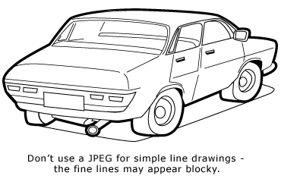

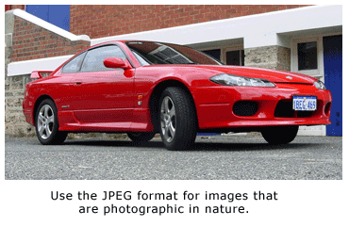

RAW is an image output option available on some digital cameras. Though lossless, it is a factor of three of four smaller than TIFF files of the same image. The disadvantage is that there is a different RAW format for each manufacturer, and so you may have to use the manufacturer's software to view the images. (Some graphics applications can read some manufacturer's RAW formats.)

BMP is an uncompressed proprietary format invented by Microsoft. There is really no reason to ever use this format.

PSD, PSP, etc. , are proprietary formats used by graphics programs. Photoshop's files have the PSD extension, while Paint Shop Pro files use PSP. These are the preferred working formats as you edit images in the software, because only the proprietary formats retain all the editing power of the programs. These packages use layers, for example, to build complex images, and layer information may be lost in the nonproprietary formats such as TIFF and JPG. However, be sure to save your end result as a standard TIFF or JPG, or you may not be able to view it in a few years when your software has changed.
Currently, GIF and JPG are the formats used for nearly all web images. PNG is supported by most of the latest generation browsers. TIFF is not widely supported by web browsers, and should be avoided for web use. PNG does everything GIF does, and better, so expect to see PNG replace GIF in the future. PNG will not replace JPG, since JPG is capable of much greater compression of photographic images, even when set for quite minimal loss of quality.

File size comparisons
Below are comparisons of the same image saved in several popular file types. (Note that there is no reason to view more than one of the TIFFs or the PNG. Since all are lossless formats, their appearance is identical.)
File type Size Image Example
1. Tiff, uncompressed 901K Not shown here
http://www.wakeforest.edu/~matthews/misc/graphics/formats/uncompr.tif

2. Tiff, LZW lossless compression (yes, its actually bigger) 928K Not shown here
http://www.wakeforest.edu/~matthews/misc/graphics/formats/lzw.tif

3. JPG, High quality 319K
From Image Types and sizes Open 03 HiQ.jpg image to see real image size -
http://www.wakeforest.edu/~matthews/misc/graphics/formats/HiQ.jpg
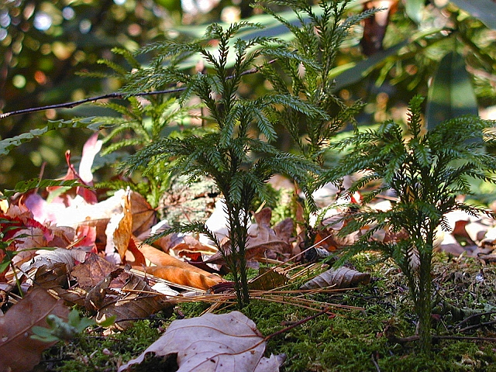
4. JPG, medium quality 188K
Open 04 MedQ.jpg image from Image Types and sizes http://www.wakeforest.edu/~matthews/misc/graphics/formats/MedQ.jpg
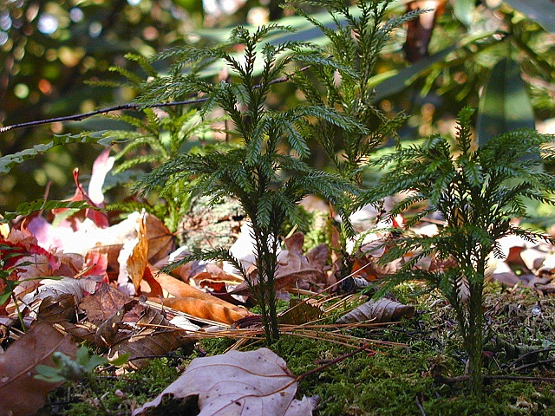
5. JPG, my usual web quality 105K 05
Open 05 WebQ.jpg image from Image Types and sizes http://www.wakeforest.edu/~matthews/misc/graphics/formats/WebQ.jpg
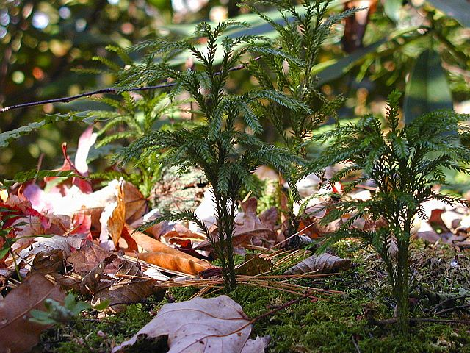
6. JPG, low quality / high compression 50K
Open 06 Lo.jpg image from Image Types and sizes
http://www.wakeforest.edu/~matthews/misc/graphics/formats/Lo.jpg

7. JPG, absurdly high compression 18K
Open 07 absurd.jpg PNG image from Image Types and sizes
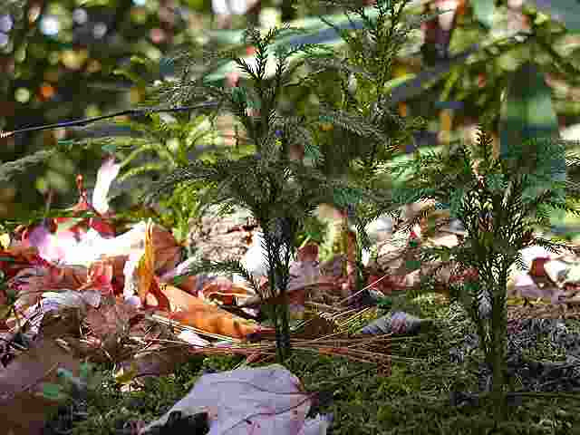
8. lossless compression 741K
Open 08 png.png image from Image Types and sizes
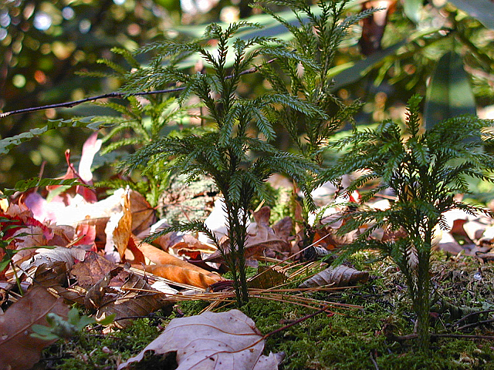
9. lossless compression, but only 256 colors 131K
Open 09 optmedcut.gif image from Image Types and sizes
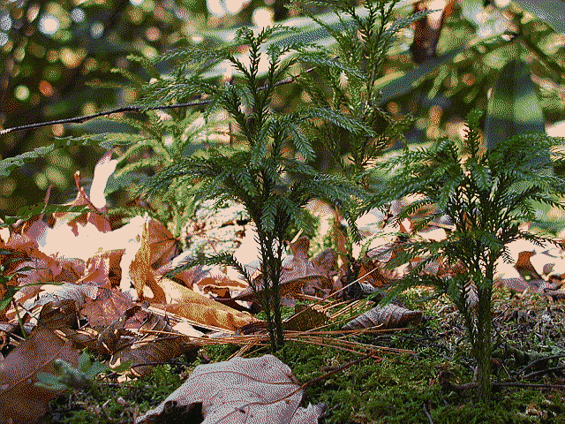

Other formats
When using graphics software such as Photoshop or Paint Shop Pro, working files should be in the proprietary format of the software. Save final results in TIFF, PNG, or JPG.
Use RAW only for in-camera storage, and copy or convert to TIFF, PNG, or JPG as soon as you transfer to your PC. You do not want your image archives to be in a proprietary format. Although several graphics programs can now read the RAW format for many digital cameras, it is unwise to rely on any proprietary format for long term storage. Will you be able to read a RAW file in five years? In twenty? JPG is the format most likely to be readable in 50 years.Thus, it is appropriate to use RAW to store images in the camera and perhaps for temporary lossless storage on your PC, but be sure to create a TIFF, or better still a PNG or JPG, for archival storage.

Related pages

* Getting started in digital photography
* Tips and info on graphics, imaging, and digital photography
* JPG vs GIF for web images
* How bad is JPG? (Large file)
* Should you use JPG or a lossless format for archiving images? (Large file.)
* Chroma subsampling in JPG
* Miscellaneous tips and info

File Types Quiz
INTRO: You have already seen that graphics files may be saved in various formats. EG BMP; GIF; TIFF; WMF; PNG; JPG and PSP. Each format has its own characteristics and uses.
Both sound and video files can also be saved in a variety of formats.

Sound files can be saved in WAV, MID; RA and MP3 formats.

Video for the computer can be in AVI; MPEG and MOV formats.

Answer the questions about graphic file types.
- What is the difference between Bit Mapped graphics (BMP) and Vector graphics?
- Give the name of a program that can edit / create each of the above types.
- For 3 of the file types below, find out whether it is a bit mapped or vector graphic; what the extension stands for; what are the characteristics of the file type, and where would you use it. EG: Power Point; web page.
- GIF;
- TIFF;
- PNG
- PSP;
- JPG
For example, BMP stands for Bitmap. This is a high quality picture format, but also results in a large file size (Why?). They can be used in Word documents or photo programs, but not on web pages. Include a small (250 X 250 pixels) picture example of each file in your assignment.
References: http://www.scala.com/multimedia/multimedia-directory.html
http://computer.howstuffworks.com/question408.htm
www.askjeeves.com and type Graphics Formats into the ask box.
- Movie / video formats. There are a number of formats for displaying video on computers. Again, some are suitable for some applications, such as power point, and others are best for the web. You are to research 3 video formats. For the following file types, find out what the extension stands for; what are the characteristics of the file type, and where would you use it. File types to be covered are:
- AVI;
- MPEG. Note – find out what a Key Frame is and a Codex; What is MPEG 2 used for?
- MOV
Your answers should be written into this file under the question number.
References: Video Man program: Help – Clips – Types of Video Data.
Virtual Dub program: Help – Contents – Intro to Digital Video
PC Tec Guide http://www.pctechguide.com/24digvid.htm
Ask Jeeves – Digital Video in Ask box.

Colour depth
Colour depth is a measurement of the number of bits of stored information per pixel. Colour depth is also called bit depth or colour resolution. This is considered a type of resolution because it can determine the number of bits used and therefore the quality of an image. Colour depth can have dramatic effects on an image and directly affects the file size.
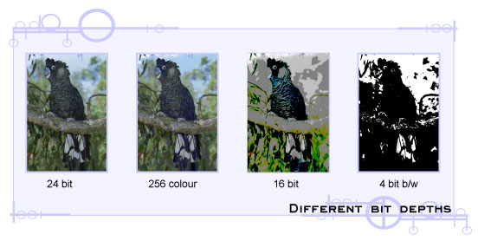

Device resolution
Device resolution relates directly to hardware like printers, monitors and scanners. The device resolution determines the number of dots or pixels that can be used to output an image. Different devices provide different resolutions, that is, they produce a different number of pixels or different sized dots. Often more expensive professional devices provide higher resolution than devices designed for the home user.
Device resolution is measured in dots per inch (dpi) or pixels per inch (ppi). A computer screen with a Macintosh® OS has 72 dpi. A computer screen with a Windows® OS has 96 dpi.
The resolution of an inkjet printer ranges from 180 dpi to 1440 dpi. The higher a printer’s resolution, the smaller the dots of ink on the page will be. At 1440 dpi, a printer can produce a photo quality print. Laser printers have resolutions of between 300 dpi and 1200 dpi.

Image resolution
Image resolution, along with device resolution is used by software applications to determine the physical size of an image. Image manipulation software can add pixels to an image when its size is increased and remove pixels when size is decreased.

Resolution and file size
The file size of a digital image is dependent on the height, width and colour depth of the image.
For example:
A 5 x 7cm image with a resolution of 200 dpi has a file size four times greater than the same sized image at 100 dpi. This is because at 200 dpi there are twice as many pixels along the height and width.
Higher resolution images contain more pixels and produce higher quality images. The downside of high resolution is the increase in file size. Selecting the resolution is a compromise between file size and image quality.
Dpi Size Pixels
72 72*72 5 184
300 300*300 90 000

Calculating file size
If an image is 640 pixels wide by 480 pixels high and the colour depth is known, the file size can be calculated.

Height x width x colour depth (in bytes) = file size
4-bit = 640 x 480 x (0.5) = 153 600 bytes
8-bit = 640 x 480 x 1= 307 200 bytes
24-bit = 640 x 480 x 3 = 921 600 bytes
8-bit = 320 x 240 x 1 = 76 800 bytes

Colour depth has a great impact on file size.

Image file formats
Every file on a computer is stored using a specific file format. This file format is used to attach information to a file which allows a computer to determine that type of data contained in the file.
When a file is saved, a three or four letter code is automatically attached to the file. This code identifies the file type or application used to create it. When a file is saved in an application, the default file format will be attached. This default is called the native file format.
For example, the native file format for a document created in Microsoft® Word is .doc.
It is common that only the original program can open the native file format. This is especially true for image manipulation software, however most programs can open several file formats providing the file is of a similar type, such as a word processed document or an image or sound file.
Most software applications have the ability to save a file in many, more common file formats. Some file formats can be opened on both Windows® and Macintosh® computers. These formats are said to be cross-platform. The advantage of this is that other programs can open the file. It is very important when creating any project that an appropriate file format is selected.

TIFF format: This is a common file format used to save images that need to be read by other imaging devices not just computers. TIFF is an acronym for Tagged Image File Format and is the leading commercial and professional image standard. It is used to archive important images because of its high quality and flexibility.
TIFF file formats attach information in the form of tags which detail the type of data contained in the file. This information can be used by image processing and printing devices to produce consistent colour and resolution without the need for direct computer control.
TIFF images are lossless and use the same compression scheme as GIF formats - LZW. This lossless compression means that a computer can always read back the exact data saved, bit by bit, without data corruption. It is this reliability which makes the TIFF format ideal for archiving master copies of images.
TIFF is a high-quality, universal standard format for saving full colour images. Important documents, images and some photographs should be stored using this format when quality is important than file size. Photographic images when saved using the TIFF format are very large.
While the large file sizes mean plenty of detail, it is not a suitable format for the web. TIFF files have a colour depth of 24 bits making them a great format for all image types.

Other formats
PICT: A general purpose image format, PICT can be used for achieving images with large areas of similar colours or borders. This format offers good compression without any loss in quality.

EPS: an acronym for Encapsulated Post Script. This format is used in desktop publishing. The Post Script language is used by printers to output documents that contain images and text.

PDF: This is the native file format created by the software Adobe® Acrobat® and a similar format to EPS. Portable Document Format (PDF) has become the standard format for electronic publishing. Documents using this format can contain images, text and sounds. The file sizes are very small making it suitable for use on the web. PDF files open in the Acrobat reader and appear exactly as the original making the format user friendly, cross-platform, and producing high-quality printouts.

